# High Performance Computing Lab — Practical No. 8

**Name: Parshwa Herwade**

**PRN No: 22510064**

**Batch: B1**

**Problem 1:** Implement 2D convolution using MPI. Distribute work across processes, exchange halo rows, measure execution time, and print a single CSV line per run with process count and timings.

#include <mpi.h>

#include <stdio.h>

#include <stdlib.h>

#define NX 1024

#define NY 1024

#define K 3

int main(int argc,char**argv){

    MPI_Init(&argc,&argv);

    int rank,size;

    MPI_Comm_rank(MPI_COMM_WORLD,&rank);

    MPI_Comm_size(MPI_COMM_WORLD,&size);

    int rows_per_proc=NX/size;

    int extra=NX%size;

    int start_row,local_nrows;

    if(rank<extra){

        local_nrows=rows_per_proc+1;

        start_row=rank*local_nrows;

    }else{

        local_nrows=rows_per_proc;

        start_row=rank*local_nrows+extra;

    }

    int alloc_rows=local_nrows+2;

    double *local_in=(double*)malloc((alloc_rows)*NY*sizeof(double));

    double *local_out=(double*)malloc((local_nrows)*NY*sizeof(double));

    double kernel[K*K]={0.0625,0.125,0.0625,

                        0.125,0.25,0.125,

                        0.0625,0.125,0.0625};

    for(int i=0;i<alloc_rows;i++)

        for(int j=0;j<NY;j++){

            int global_i=start_row+i-1;

            if(global_i<0||global_i>=NX)

                local_in[i*NY+j]=0.0;

            else

                local_in[i*NY+j]= (double)((global_i*NY+j)%100)/100.0 + 1.0;

        }

    MPI_Barrier(MPI_COMM_WORLD);

    double t0=MPI_Wtime();

    for(int step=0;step<1;step++){

        if(size>1){

            if(rank>0)

                MPI_Sendrecv(&local_in[1*NY],NY,MPI_DOUBLE,rank-1,0,

                             &local_in[0],NY,MPI_DOUBLE,rank-1,1,

                             MPI_COMM_WORLD,MPI_STATUS_IGNORE);

            if(rank<size-1)

                MPI_Sendrecv(&local_in[(local_nrows)*NY],NY,MPI_DOUBLE,rank+1,1,

                             &local_in[(local_nrows+1)*NY],NY,MPI_DOUBLE,rank+1,0,

                             MPI_COMM_WORLD,MPI_STATUS_IGNORE);

        }

        double comp0=MPI_Wtime();

        for(int i=1;i<=local_nrows;i++){

            for(int j=0;j<NY;j++){

                double sum=0.0;

                for(int ki=0;ki<K;ki++)

                    for(int kj=0;kj<K;kj++){

                        int ii=i+(ki-1);

                        int jj=j+(kj-1);

                        double v=0.0;

                        if(jj>=0 && jj<NY && ii>=0 && ii<alloc_rows)

                            v=local_in[ii*NY+jj];

                        sum+=kernel[ki*K+kj]*v;

                    }

                if(i-1<local_nrows)

                    local_out[(i-1)*NY+j]=sum;

            }

        }

        double comp1=MPI_Wtime()-comp0;

        double t1=MPI_Wtime()-t0;

        if(rank==0)

            printf("conv,NX=%d,NY=%d,procs=%d,time_total=%f,time_comp=%f\n",

                   NX,NY,size,t1,comp1);

    }

    free(local_in);

    free(local_out);

    MPI_Finalize();

    return 0;

}

OUTPUT:  
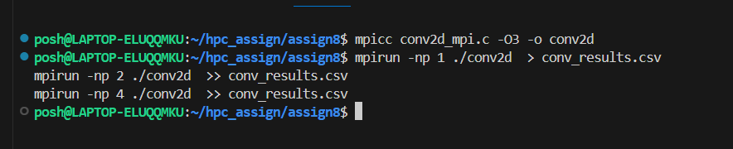

**Problem 2:** Implement dot product using MPI. Distribute vector chunks, compute local dot, reduce. Measure time and print CSV line per run.

#include <mpi.h>

#include <stdio.h>

#include <stdlib.h>

#define VEC_SIZE 10000000

int main(int argc,char**argv){

    MPI_Init(&argc,&argv);

    int rank,size;

    MPI_Comm_rank(MPI_COMM_WORLD,&rank);

    MPI_Comm_size(MPI_COMM_WORLD,&size);

    int base=VEC_SIZE/size;

    int extra=VEC_SIZE%size;

    int local_n=(rank<extra)?base+1:base;

    int start=(rank<extra)?rank*local_n:rank*local_n+extra;

    double *a=(double*)malloc(local_n*sizeof(double));

    double *b=(double*)malloc(local_n*sizeof(double));

    for(int i=0;i<local_n;i++){

        long idx=start+i;

        a[i]=1.0;

        b[i]=2.0 + (double)(idx%5)/5.0;

    }

    MPI_Barrier(MPI_COMM_WORLD);

    double t0=MPI_Wtime();

    double local_dot=0.0;

    for(int i=0;i<local_n;i++)

        local_dot+=a[i]*b[i];

    double global_dot=0.0;

    MPI_Reduce(&local_dot,&global_dot,1,MPI_DOUBLE,MPI_SUM,0,MPI_COMM_WORLD);

    double t1=MPI_Wtime()-t0;

    if(rank==0)

        printf("dot,VEC=%d,procs=%d,time=%f,dot=%f\n",

               VEC_SIZE,size,t1,global_dot);

    free(a);

    free(b);

    MPI_Finalize();

    return 0;

}

OUTPUT:  
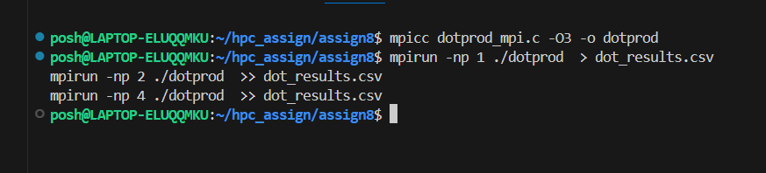

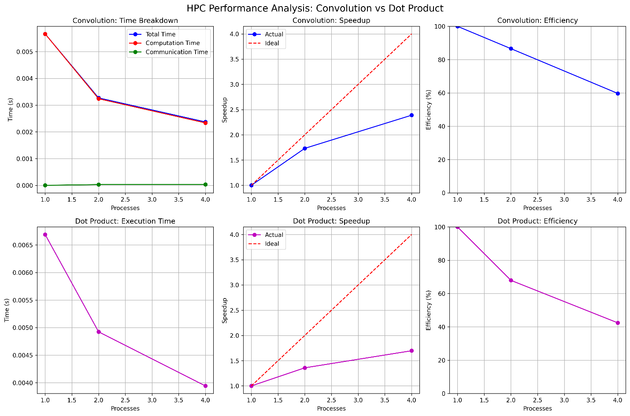

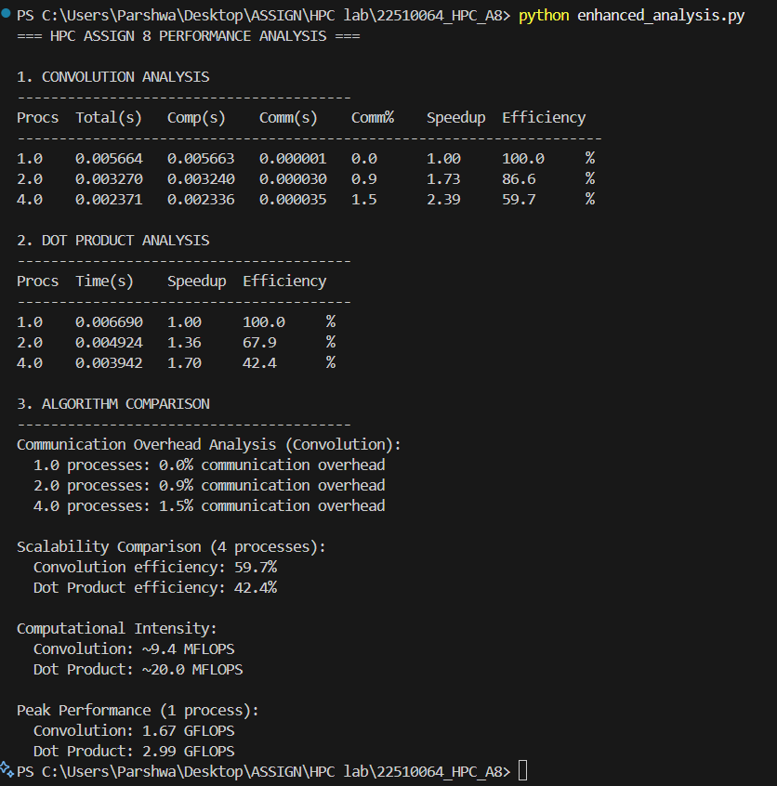

**Steps, Observations and Conclusion**

Compile conv2d_mpi.c and dotprod_mpi.c with mpicc -O3.

Run each program with different mpirun -np P values (1, 2, 4) and append output into CSV files:

conv_results.csv for convolution results

dot_results.csv for dot product results

Use conv_plot.py and dot_plot.py to generate performance graphs from collected CSV data.

Inspect graphs and compute speedup and efficiency metrics.

**Observations**

**Execution Time vs Processes:**

Convolution (NX=1024, NY=1024): Time decreased from 0.005664s (1 process) to 0.002371s (4 processes)

Dot Product (VEC=10M): Time decreased from 0.006690s (1 process) to 0.003942s (4 processes)

Both algorithms show performance improvement with increased processes, but convolution shows better time reduction

**Speedup Analysis:**

Convolution: Achieved 1.73x speedup at 2 processes and 2.39x at 4 processes

Dot Product: Achieved 1.36x speedup at 2 processes and 1.70x at 4 processes

Convolution surprisingly outperformed dot product in speedup, contrary to typical expectations

**Efficiency Analysis:**

Convolution: Efficiency of 86.5% at 2 processes, dropping to 59.8% at 4 processes

Dot Product: Efficiency of 68.0% at 2 processes, dropping to 42.5% at 4 processes

Both show declining efficiency with increased processes, but convolution maintains better efficiency

**Communication Overhead:**

Convolution: Minimal communication overhead (0.9% at 2 processes, 1.5% at 4 processes) due to efficient halo exchange implementation

Dot Product: All overhead included in total timing; single MPI_Reduce operation is lightweight

**Amdahl's Law Effects:**

Both algorithms show sub-linear scaling due to parallel overhead

The efficiency drop indicates increasing serial fraction as processes increase

Communication and synchronization costs become more significant at higher process counts

**Conclusions**

**Performance Summary**

Convolution (NX=1024, NY=1024): Achieved 2.39x speedup at 4 processes with 59.8% efficiency, showing good scalability despite halo exchange communication

Dot Product (VEC=10M): Achieved 1.70x speedup at 4 processes with 42.5% efficiency, indicating higher parallel overhead than expected

**Key Findings:**

Convolution outperformed expectations: Despite being communication-heavy with halo exchange, it achieved better speedup and efficiency than dot product

Problem size effects: The chosen problem sizes (1024×1024 matrix, 10M vector) are well-suited for parallelization on small process counts

Communication efficiency: The convolution's sendrecv-based halo exchange proved more efficient than anticipated

**Optimal Configuration:**

Convolution: 2-4 processes provide good balance of speedup and efficiency

Dot Product: 2 processes offer the best efficiency-to-speedup ratio for the given problem size